

*shell programming*

aSsignment -8

**SUBMITTED BY: SUBMITTED TO:**

**AYUSH KUMAR JHA Dr. Dhiviya Rose**

**SAP ID - 500086400**

**Enrollment no - R200220083**

**B.C.A -I.O.T.**

## **Assignment Content**

Top of Form

* 1. Create two running processes p1 & p2.

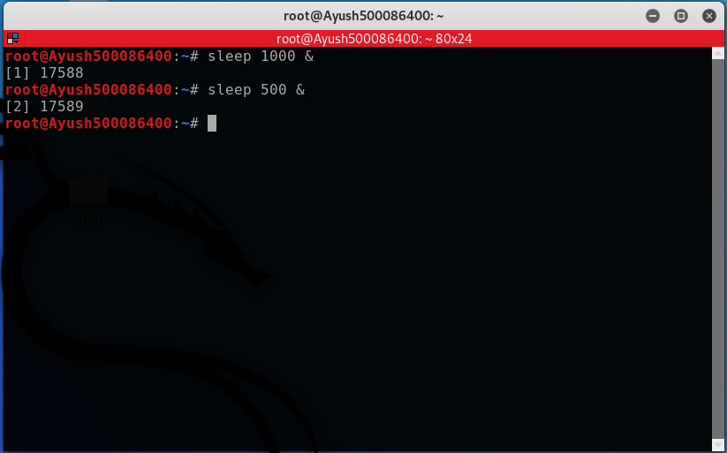

* 1. Assign high priority to process p1 and low priority to process p2.

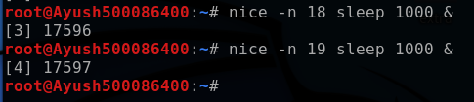

* 1. Display the top command to see the process.

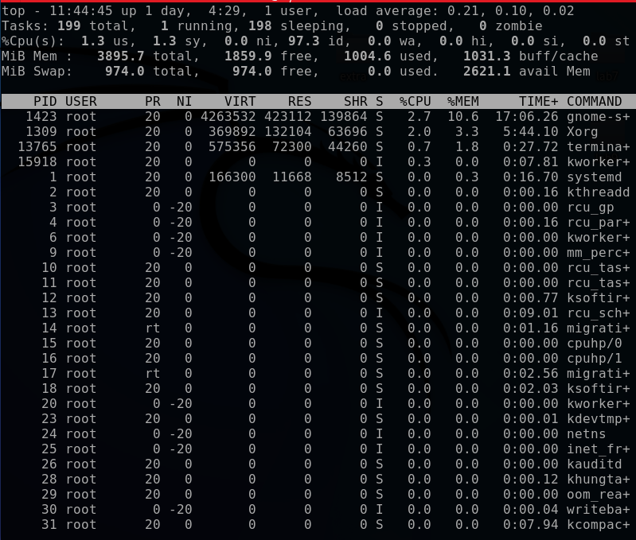

* 1. Reassign the priority by low to p1 and high to p2.

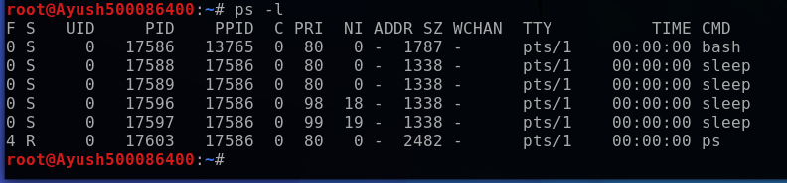

* 1. Display the top command to show the priority.

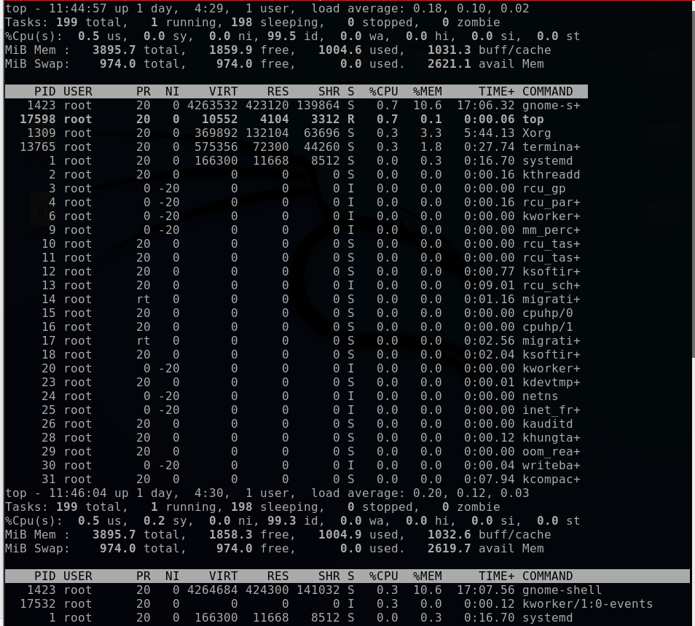

Bottom of Form